Hello Dancers and Parents!
The middle of August has found its way into our lives and the beautiful sunsets are gifting us fond memories as we step towards fall. I do hope that you have all had a great summer with fun, fabulous food and lots of sand between your toes.
After we finished the show in May, it took our videographer quite the time to narrow down the video for the final cuts, but we finally did that in July. I have those videos ready to pass to you. If you would like to send me a message of when you can meet me, I would be happy to pass them. Starting this Saturday I will be in Port Hawk on Saturday from 12 – 2:30 in the dance studio at the Civic Center, in Belle Cote Hall on Monday the 26th 9 – 12pm, at the Judique Hall on Tuesday the 27th from 6 – 9 pm, at the Renewal Center in Mabou on the 29th from 6 – 9 pm. If you would like to stop by my home, just drop me an email.
For those that were part of the interviews for the documentary, it is in its preliminary stages of being compiled and we will add more this fall as we get into the new materials of learning!
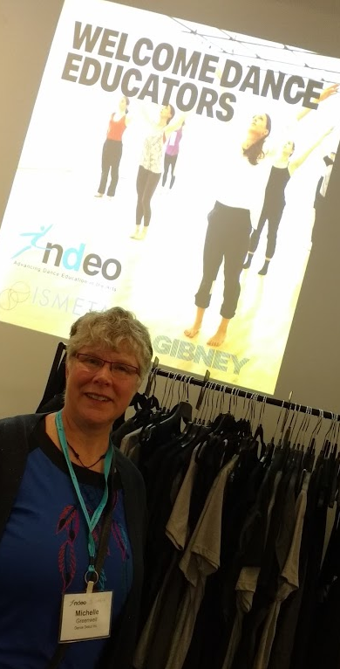
Since I last saw you, we had a special paint event to test out a project of putting tap shoes to canvas and painting our own paintings as we had used last year in the program. This project was a little more difficult than we all imagined, but some wonderful paintings were produced. Two of them were entered in the hands dancing exhibit at the Inverness Arts Center in June. We saved this as part of the documentary as well….and more will be coming.
In June I was able to present our Dance Warmup for the National Dance Educators Organization and the International Somatic Movement Education Therapy Association in New York City. This was a dream trip for me, but also a landmark for all the work that we put into our dance last season. Since that trip the Dance Warmup has been renamed: “The BioEnergetic Wellness Dance Warmup” and has been shared by professors of dance across North America and in Europe and China. A beautiful ballet teacher named Annemari Autere from France shared her approach to “The Feeling BalletBody” (her book title), and it was a match to what we were doing. This has inspired some of the ballet character work for this season. Annemari is sharing the dance warmup across Europe as she has been teaching at conferences throughout the summer. I will cross paths with her in Montreal in October for the International Association for Dance Medicine and Science. I will be expanding the knowledge of the 5 Elements and the meridians (which we danced with the scarves in the opening of the show) with muscle power.
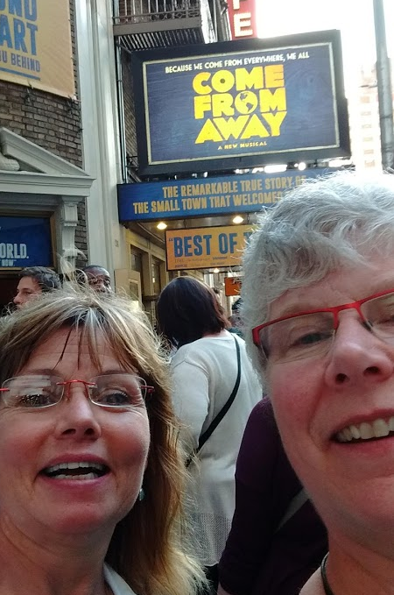
While in Time Square I was able to see “Come from Away”. This is the musical about the planes that landed in Gander Newfoundland after the attacks on 9/11. If you have a chance to see this musical, it is brilliant, and you can feel and understand the characters so well as they mimic much of what we experience here on Cape Breton Island. August 29th Anna Ludlow, the fiddler for the Toronto cast of the show, will be performing at the Red Shoe Pub from 8 – 10 pm. She is originally from Antigonish area and is a beautiful person and performer. She is releasing her new CD at this event as well as many events on the mainland. (Just a little aside, but please see the Come From Away if you get the chance!).
Stepdance Camp with Melody Cameron for a third season was another highlight of dancing this summer. Sharing with long time dance friend, Rhonda Gillrie (Pictured in NY with me) from Danceology in Stettler, Alberta, and my son, MacKenzie, we had some deep discussions around the table each night about patterns in dancing, the intricacies of the movements, and creating atmosphere with the feet – just light conversation. This has inspired adding a few celtic classes (as requested by some of the dance parents), as well as playing with stories and patterns in movement for some themes as well this season! When my feet were dancing Seann Truibhas quadruple shakes in the ocean, I knew I needed to bring a little highland dancing and stepdancing back into my regular class times.
This leads up to my last inspiration for setting the program this season, the arrival of the Jorgen Ballet with “Anne of Green Gables” the Ballet, in April!!! My long-time friend and fellow highland competitor, Rhonda Gillrie, was the dance teacher to nurture the early years of one of the dancers touring with the Ballet company. We are currently working on preparing a project between our studios to link us to this ballet dancer’s career to inspire our budding dancers to imagine the best and to be that throughout the year! We will work with some of the music from the musical and prepare a large group piece of our own for the spring show.
It has been quite a summer to inspire the ideas for the new season. I have created several new music files on Spotify with both Children’s music, Ballet music and stories, and Contemporary music. You can find them under Michelle Greenwell on Spotify. Most intriguing to me is the storytelling with ballet music of some of the kid’s favorite movies…Cinderella, Cars, Toy Story…yes, the real classics ! These stories are great before bedtime or in the car and tell a story with the classical music in the background. Great to let little minds create and pretend with during their playtime!

The Fall Schedule!!!
I will attach the full schedule and descriptions in a separate document. I would like to see the Dance Club 2’s on the first day to discuss some special projects which can include tap shoes or not…I will leave it to them. Dance Club 1’s and 2’s will have a special workshop day to bring them together in September, and another one in the spring to create a chance for them to all create with a little more time than class time can allow. Once I have registration I will know where the best location and time will be.
Second- hand shoes!!! If you have shoes that can be passed forward, please bring them with you to the first class. I do have some ballet shoes still left from last year, so I will try to match to as many people as possible. I don’t have much tap shoes in my bag at this time, but hopefully the trading will begin and get shoes across the communities easily in a couple of weeks. Thank you for sharing if you can.
Whycocomagh is added in with Waycobah. For those who would like to dance in Whycocomagh, we will be at the Waycobah school in the cafeteria area. Please pass the message forward if you know of someone wanting to join dance class.
Adult dance class: By request, I have added a few classes extra into the schedule this year. I have a dance class, as well as the Qi YINtegration class will be focused on movement and music combining Tai Chi and Dance in choreographed routines. For those wanting something a little more than just a workout class, this will provide you with tools to energize and revitalize. I hope you will join me!
The full schedule is posted with the calendar year delineated as best as I know at this point. I will be in Toronto and Montreal to do two presentations in October, and I will be away in December for a special trip, that is why the schedule for the fall has a couple of week breaks in it. I put the dance payments into two semesters for ease of collecting. Everything is pretty much the same as last year. If you are using a check for an Inverness County class, please make the check to them, as it will run through their office. In Port Hawkesbury the payments come directly to me and the checks can be to Michelle Greenwell. In Waycobah/Whycocomagh the payments can go to the Waycobah recreation office, and Wally will take care of them.
Thank you everyone for all that you have inspired and continue to do so with. I look forward to seeing little sprouts who have grown into big sprouts, and to preteens who have grown into creative and inspired dancers for our personal choreography section this fall! See you on the dance floor soon!
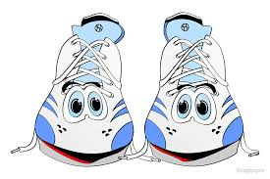
Michelle Greenwell
Dance Debut’s 2019-2020 Season
“If These Shoes could Talk”!

