Creating and Dancing with Prayer Flags!

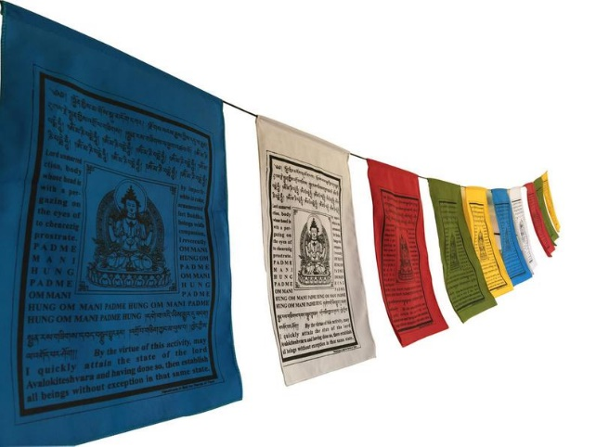
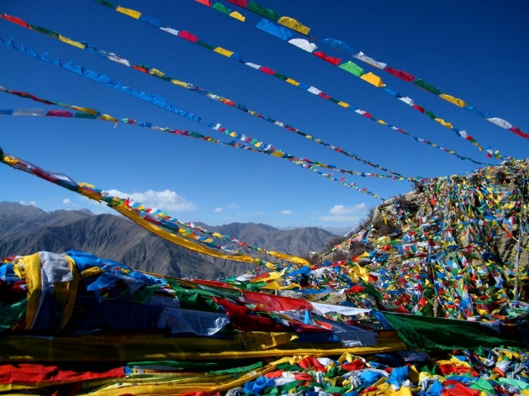

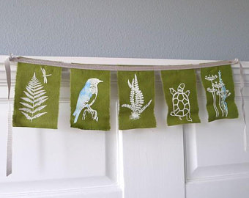
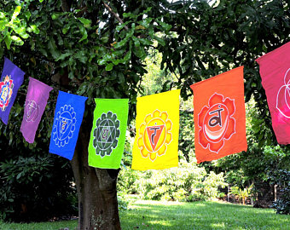
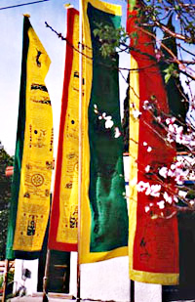
To learn a little more about the prayer flags:
https://www.indiatimes.com/lifestyle/self/8-things-you-should-know-about-tibetan-prayer-flags-before-hanging-them-up-257899.html
http://www.thepeaceflagproject.org
Google: ideas for making prayer flags with kids

