Tai Chi Cape Breton Fall/Winter Newsletter
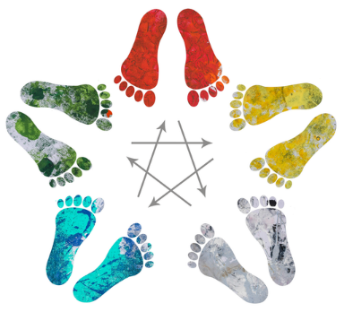
Congratulations on the success of our Fall workshop. The opportunity to have a collaborative workshop with Doug, Yvonne, and Michelle created a strong learning opportunity for the club, as well as the instructors. A big thank you to everyone who participated, filled out evaluation and reflection forms, supported the event, and shared their insights. This was a great jumping off point for our learning this season!
The theme for October and November is the 5 Element Wheel and Theory as it relates to Tai Chi. Here are some of the details you can look for in the upcoming classes.
The need for relaxation in your Tai Chi practice. Using the singing bowls, we will explore the level of tension that is held in the body on a regular basis, and the amount of release required to create a flow of energy through the body. This is always surprising, and something that can be important throughout the day to keep the flow continuing after Tai Chi practice. This is something you can share with a friend, and together you can support each other both in class and outside of class.
Intention Setting up your purpose and goals for class, and for long term objectives is important to the information that you will gleam from your time in class. Take a look at your reason for coming to Tai Chi in the first place. Write that idea down and create a visual of what it is you want to be doing as a result of the health and wellness that Tai Chi can create for you. Next, before class, consider what you are needing in knowledge, flow in the body, movement options. This focus will find a way for the right information to find you, as well as the experience of the movements to flow and change for you to meet your goals. Lastly, consider how your involvement in the class affects and creates opportunities for others. Can you assist with taking the corner to set the pace of the set? Can you assist someone who is new to the class and may have questions? Can you provide feedback about what you are learning and how you are growing with the information? All of these ideas expand your opportunity for getting the most flow and benefit from Tai Chi and being a part of the club.
EMOTION
How does the emotion that you carry create the posture that you use? We will explore this angle of the 5 Element Theory as we learn more about which emotions are a part of which element and how an imbalance can create a specific posture. As well, what happens if you practice Tai Chi from a place of love, joy or gratitude? We will explore how this changes the flow of energy within the set, and the overall feeling of the group when the goal is created for everyone.
This leads us to Color and Sound
How does color and sound affect the flow of energy. Can you sense this, and can you explore how the Ko or Shen cycle can be opened to create a balance and ease of movement through the body? We will explore breathing and making sounds that relate to the 5 Elements and bring that back to the Tai Chi sets to optimize your goals and ambitions in health and wellness.
To Give and To Offer
We explored the difference in tension in the body when we give ourselves something because our mind/ego determines we need it, and if we offer ourselves assistance. The body/mind/spirit has the opportunity to take what it needs and leave the rest. This reduces the tension experienced by the body and changes the resulting movement capabilities and relaxation. As you reflect on your languaging in conversation: “Do this”, “You need to”, “I told you”, “I have to”. You can find ways to offer: “Consider this”, “Perhaps you would like to”, “I suggest”, “It is possible”.
The fall class schedule continues with the following classes being offered:
Mondays: Belle Cote Community Hall 10 -12 pm (10 Tai Chi, 11 Sabre, 11:15 Loh Kup)
Tuesdays: Judique Community Hall 7 - 8:30 pm (7 Tai Chi, 8 Sabre, 8:15 Loh Kup)
Thursdays: Dalbrae Academy Classroom in Mabou 7 - 8:30 pm (7 Tai Chi, 8 Sabre, 8:15 Loh Kup)
Fridays: Belle Cote Community Hall 10 - 11 am (Practice time for students)
Saturdays: Port Hawkesbury Civic Center Dance Studio 12 - 2 pm (12 Tai Chi, 1 Sabre, 1:15 Loh Kup)
The cost for class continues to be $45 for 4 months, with the next membership dues being collected the second week of September, for classes from September to December.
We have a special class at the Inverary Manor in the Rodney MacDonald Music Room on Fridays for 1-2 pm. Members of Tai Chi Cape Breton are welcome to join us. The classes are offered in 8 weekly sessions, send an email to confirm your attendance to the class. info@dancedebut.com.
If Dancing is your thing…we have two Adult dance classes using similar themes to those listed above. Belle Cote – at Cape Breton Academy on Monday nights from 6:40 – 7:40. At the Port Hawkesbury Civic Center dance studio on Saturday afternoons from 3 – 4 pm. Please confirm your attendance to these classes. New students welcome.

Tai Chi Wellness and the Seated Form Series
In October the Series was launched!!! Thank you to everyone who supported and participated in creating the materials for this series. We are now open to the public on Youtube and Facebook: Tai Chi Wellness and the Seated Form Series. Please share the links with all those who could benefit from learning more about movement, wellness and how to integrate the seated form into everyday activities. What can you expect? For the next 6 months there will be a new video released each week. The facebook page will be a place to connect with others to share information, to provide feedback and experience, and to learn more about the seated form.
Our second workshop to launch the series was at Wine Country Tai Chi Society (Oct 21 and 22). With two days of exploration, there was a weaving of information about self-awareness, the seated form and the 5 Element Theory. It was quite an adventure with many personal stories of success including elimination of pain, the release of neuropathy, freedom of movement, and the critical – how to get up and down from a seated position with no effort!
Tai Chi Wellness Webinars
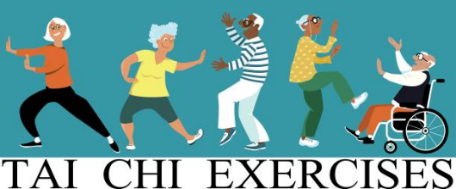
As part of the program developed with the Video Series, we will be launching a monthly gathering for people involved in the series. This is a place to learn a little more, develop their Tai Chi on a personal level, and to expand the experiences both in and out of class time. The first webinar will be launched in January. If you wish to be a part of this series, check out the event posting on the Facebook page: Tai Chi Wellness and the Seated Form Series, or find the blog post on www.dancedebut.com. Our introductory session will be free on November 17th at 8 am Pacific and 12 pm Atlantic, just sign up on Facebook or with a message to Michelle. The cost for the regular webinar will be $10 plus HST, with the money raised from the program to support future Videos resulting from the knowledge gained with the program. We will be using “Zoom” to create the online presence which provides the opportunity to record the sessions and have them available after their scheduled time. To register for the series, please message Michelle at info@dancedebut.com.

See you on the Tai Chi Floor,
Michelle Greenwell,
Tai Chi Cape Breton
Celebrating 9 Incredible Years!

