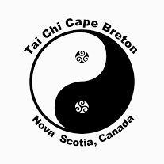
Tai Chi Cape Breton - Tai Chi for Health and Wellness!
Tai Chi is an all-encompassing means of assisting the energy in the body to flow easily and fluidly through the organs and systems to assist with optimum health. The deep breathing, simple postures and patterns of movement help the Tai Chi’er to create an atmosphere of relaxation, calmness and consciousness. It is a way of life and an activity that weaves throughout all the actions in a day. Because of its involvement in all that we do, practitioners enjoy gathering as often as possible to continue to support the body and life with the gifts that Tai Chi offers. In Inverness County we have 4 locations, please come and join us!
Monday Belle Cote Community Center 10am -11 Tai Chi, 11 – 11:20 Sabre, 11:20 – 12pm Loh Kup
Tuesday Judique Community Center 7 – 8:15pm Tai Chi, 8:15 – 8:30 Sabre
Thursday St Joseph’s Renewal Center (Mabou) 7 – 8:15pm Tai Chi, 8:15 – 8:30 Sabre
Friday Belle Cote Community Center 10am – 11:15 Practice
Saturday Port Hawkesbury Civic Center Dance Studio 10:30am – 11:30 Tai Chi, 11:30 – 11:50 Sabre, 11:50 – 12:30 Loh Kup

Cost: $45 for 4 months, collected in January, May and September.
Come Join us!

