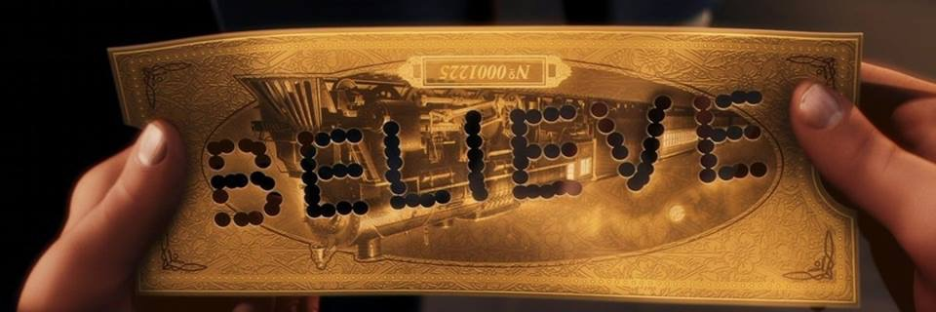 “The Little Train that Could” Find out how one dance studio is changing the way performance is shared with her dance students in a professional atmosphere!
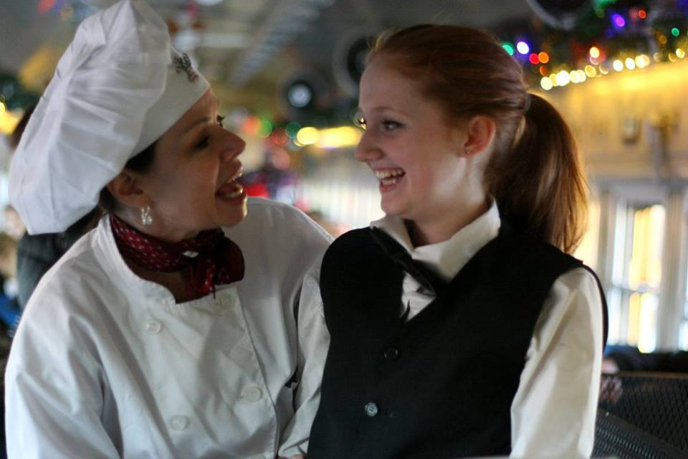
As Stettler, Alberta has just completed its second season of the Polar Express Showcase, the dancers have completed over 45 shows across 4 weeks, serving over 12,000 guests, (about 300 per show), and performing to guests in their matching pajamas and family clusters. This celebration performance brings the magic of Christmas to life for many who have forgotten how to BELIEVE. And, in two years they have performed for almost 25,000 people and this year brought over $3 Million in tourist revenue to the area.
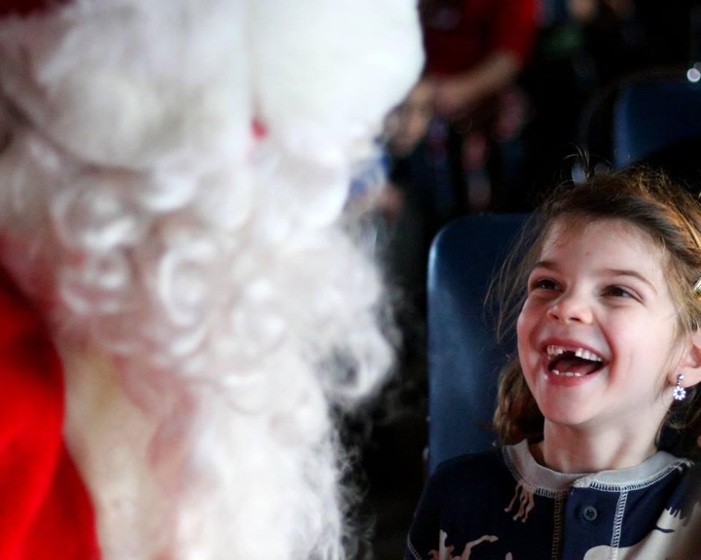
Warner Brothers observed this production, in their first year, and on their 2nd run and ranked the performance as in the top 16 in the world. By the end of the first season run they were re-evaluated as 2nd in the world for performing the Polar Express. “It is a dream come true” says Rhonda Gillrie, the Choreographer and Director of the production. “I envisioned the possibility just over 5 years ago and then when the Alberta Prairie Steam Train owner, Don Gillespie, entered into conversation of possibilities I knew it was going to reach reality."
The dancers have left the world of perfecting tricks and striving for a medal. They have taken their love of dance to the ultimate experience, the opportunity to bring joy and laughter to many, many people. This skill building goes beyond anything Miss Rhonda could create in the studio. “We performed at -30 Celsius for many shows and we had huge snow fall to step through. As well, we had a sound system malfunction that challenged one of my 12-year-old dancers to sing the songs acapella and to lead the sing-a-long songs on her own. She was outstanding in stepping up to the task before her, “exclaims Rhonda with a proud look in her eye.
Performers were excited to watch the transformation of guests, those shy parents or grandparents who had stopped believing and didn’t want to participate in the carols or activities. Then, after arriving to the North Pole and seeing Santa Claus there was a transformation. When everyone got back on the train with their magical bell they were giggling and laughing – making eye contact. The train was buzzing with excitement all the way home.
This experience has extended Rhonda’s passion for dance. Her dancers are interested in doing more performance for the community. They have developed other themes for other train rides. They have done a western with line dancing, a Scottish set with a Cape Breton square set and a trip to the pumpkin patch for Halloween which included picking a pumpkin. “The sky is the limit for ideas. I am currently working on an ‘Unbirthday Party’ with Grandma and a tea party, ‘Superheros’, a ‘Plaid Western,’ a ‘Princess and Knights’ and more.
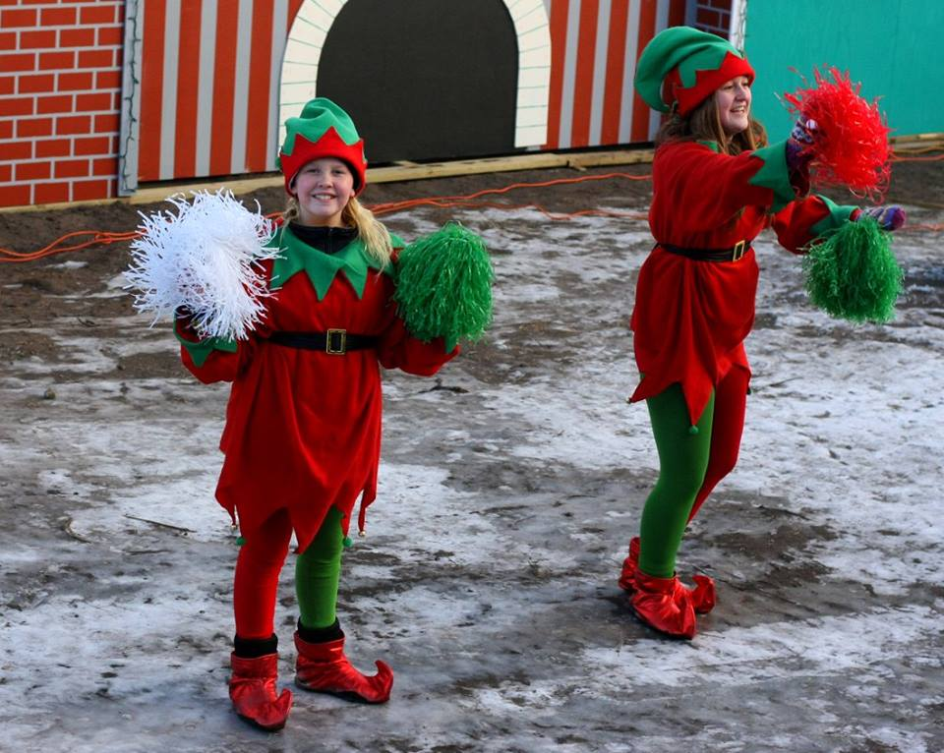
“My students have been paid for their professional involvement, unheard of for children in the professional dance world. And the full development of the show has brought people skills, performance raising, special character building and so much more, especially at -30 Celsius in the winter,” boasts Rhonda. “This project has opened my eyes to providing more exploratory, purposeful performance for my community.”
Due to these special projects, Rhonda is inspired to do different skill teaching as well as creating expanded knowledge for all involved. The bonding within our community with this event has opened us to viewing from around the world. The performers are inspired by the people who have flown into the Edmonton Airport and rented a car, travelling from Europe and the United States. “How grand is that?” Rhonda grins.
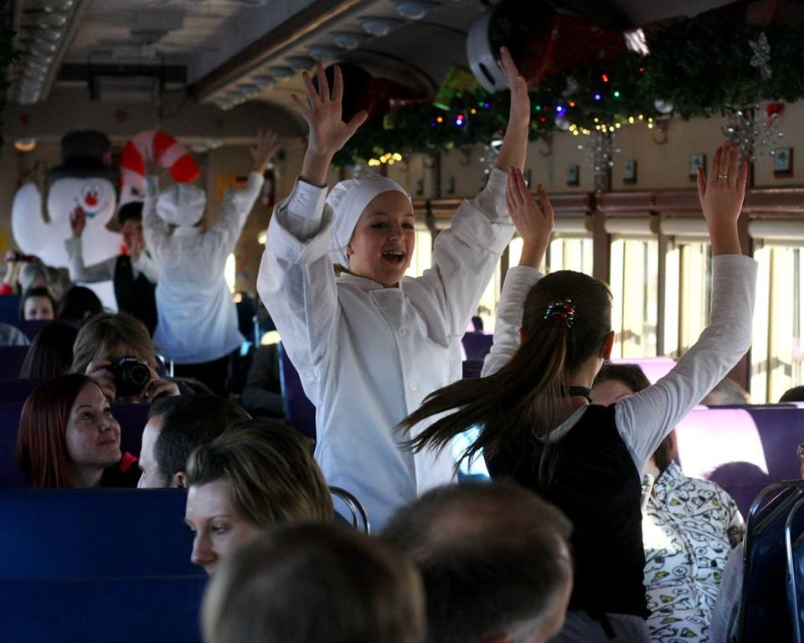
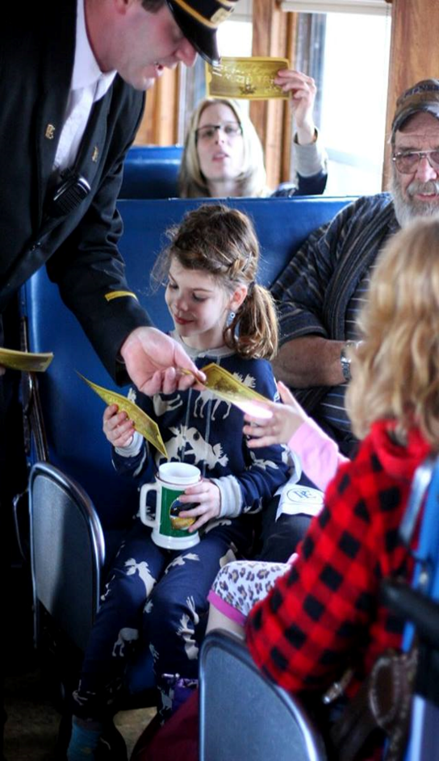
Interviewing some of the performers as to why they would do so many shows in such cold conditions brought some very heartwarming answers. “This is something I can do with my friends and it is a great opportunity for me. And, I love trains. I get to do many runs on the train,” exclaims Arielle. “This is my first job experience. It is so much fun to connect with the people and to see the little ones smile when they see Santa,” boasts Chloe. “I thought it would be a great opportunity to act and dance together in a professional environment,” states Madison a grade 12 student. This is something not usually possible in a small, rural town like Stettler. When I asked what a highlight was, Evie giggles about losing her mittens and having her team mates find them for her. They became the “Mitten Squad”. And, when the conductor started doing the ticket snipping with the fingers, “our excitement would just rise in anticipation of what was going to transpire for our guests.”

Other communities may not have a real train to work with, but the chance to bring performance opportunities to our youth that is not competitive is imperative. We need to get beyond the “win” to the sharing and to expansion of celebration in our community. Competition where the proceeds go to charity is commendable, but it is still competition oriented. The true nature of performance, to bring a full show to an audience, creates a completely different atmosphere of inclusion and experience. There is a blending of skill, age and generations. This might be the true triple threat of performance.

Choreographyer and Studio Owner, Rhonda Gillrie, can be found at Rhonda McCulloch’s Danceology in Stettler, Alberta, www.danceology.ca.
Author, Michelle Greenwell is a former studio owner who now brings Touch for Health and Whole Body awareness programs to dance studios and performers. She can be found at www.dancedebut.com.
Photo credits to Sandy Clarke© 2017

